Voel Paradys User Manual

# Home Screen

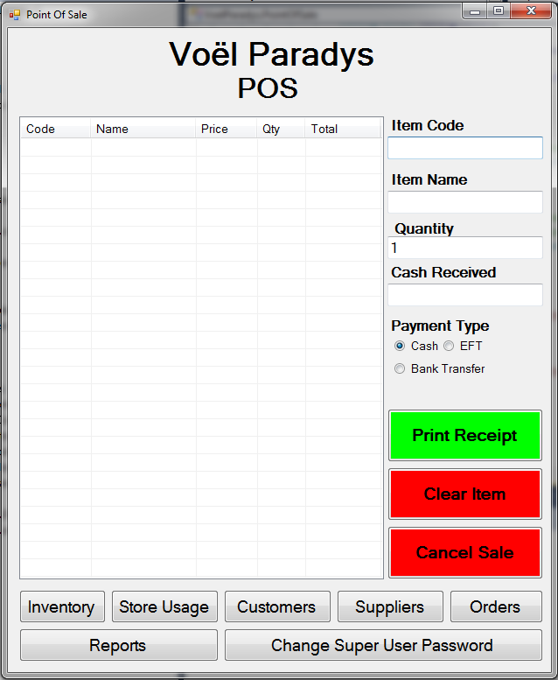

14

9

16

13

12

11

10

15

8

7

6

5

4

3

2

1

The home screen is the main operating screen, and all other windows will return to this window.

1. Allows the item code to be entered. If the customer is only purchasing one of the items, then enter can be pressed. Note that the item must exist in the database before the entered item will be accepted. The item code must also be entered exactly as it is in the database.
2. Allows the item name to be entered. If the customer is only purchasing one of the items, then enter can be pressed. Note that the item must exist in the database before the entered item will be accepted. The item code must also be entered exactly as it is in the database.
3. Allows the quantity of the item to be entered if more than one item is being entered.
4. The amount of cash received from the customer is entered here. Enter must be pressed after the amount is entered so that the value is accepted and the change calculated.
5. The payment type can be selected here. If **EFT** or **bank transfer** is selected then the total of the sale must be entered as the cash received to balance the values (this is not strictly enforced, and a receipt can still be printed without receiving any cash).
6. The **Print Receipt** button is used to print a receipt for the customer, but it also informs the app that the sale should be considered as final, and a record of it is written to disk. It is only at this point that the quantities will be subtracted from the inventory.
7. The **Clear Item** button can be used to clear a selected item from the sale. An item must be selected before any item is cleared. If nothing is selected, then nothing will happen.
8. The **Cancel Sale** button can be used to clear the whole sale of data. The form will be completely cleared, and no changes will be made to the inventory.
9. The **Sale Form** holds all the information for the current sale. Here an item to be sold can be selected, the quantity edited, or the whole item removed from the sale.
10. The **Inventory** button opens the inventory window. This window is password protected. It allows new items to be added, or stock quantities to be updated when received.
11. The **Store Usage** button opens the store usage window, where items can be selected to be used in the store.
12. The **Customers** button opens the customers window. This window allows new customers to be added, or wish list items to be added to specified customers.
13. The **Suppliers** button opens the suppliers window. This window allows new suppliers to be added, or details about the supplier can be displayed.
14. The **Orders** button opens the orders window. Here the wish list items for a customer can be signed off, or new wish list items added.
15. The **Change Super User Password** allows you to change the password required to enter the inventory window. This is the only password that is available in the app. No other user information is stored.
16. The **Reports** button opens the reports window. This window allows different reports to be viewed, exported or printed.

# Inventory

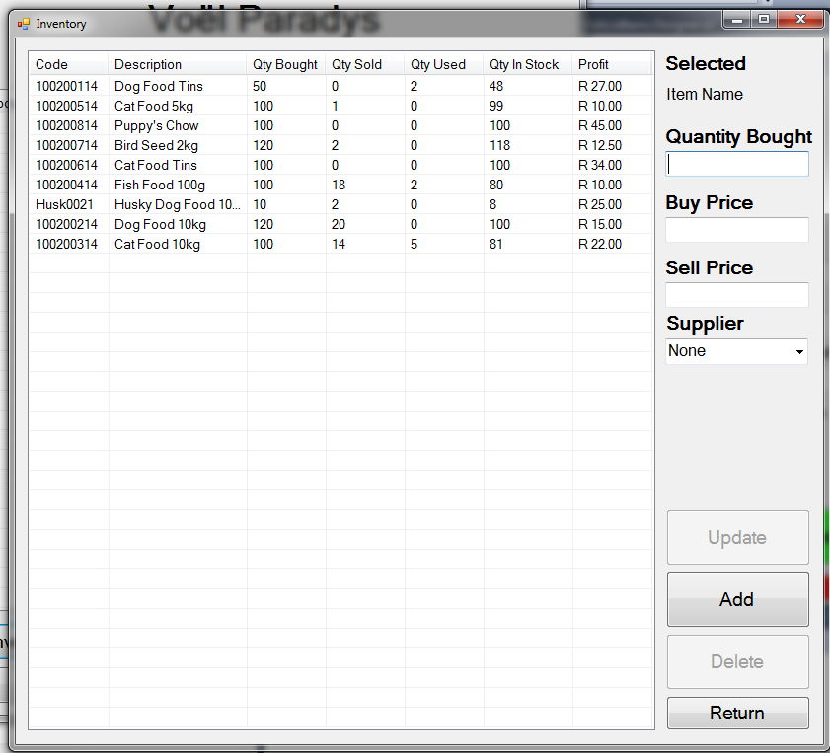

10

9

81

7

6

5

4

3

2

1

The inventory screen is where all the inventory of the store gets managed. Here you can add new inventory items, update existing inventory items or delete a selected inventory item. Since the inventory is password protected, if this dialog loses focus (pressing anywhere else on the screen) then the dialog will close.

1. The selected items name will appear here. No other changes can be made to the items name or code.
2. The quantity bought can be entered here. The amount entered here must be the amount that was recently bought. The app will add the new amount entered with the previous amount.
3. Here the buy price can be entered. The value entered here will override the previous value. So if there is old stock still available, it will be priced with the new stock at the new buy price.
4. Here the sell price can be entered. The value entered here will override the previous value. So if there is old stock still available, it will be priced with the new stock at the new buy price.
5. Here a supplier can be selected to be assigned to the currently selected item. It is not a requirement that a supplier must be selected. If the supplier is not part of the supplier database, then the supplier must first be added to the database before the assignment can be done.
6. The **Update** button allows the selected item to be updated with the values entered at 2, 3, 4 and 5. If no item is selected, then the button will be disabled.
7. The **Add** button opens the add inventory window where new inventory items can be added.
8. The **Delete** button allows the selected item to be deleted. If no item is selected, then the button will be disabled.
9. The **Return** button returns to the **Home** screen.
10. The inventory form displays all the inventory items that have been entered into the database (in no particular order). Whether there is stock available of the item or not.

# Add Inventory

5

4

3

2

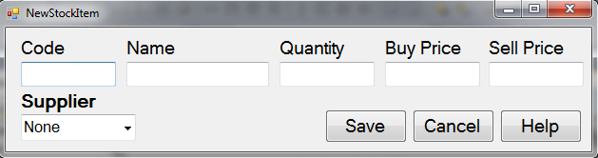

7

8

9

6

1

The add inventory dialog allows a new stock item to be added to the database. Since the inventory is password protected, if this dialog loses focus (pressing anywhere else on the screen) then the dialog will close, and the input cancelled. All fields are required for the stock item to be valid. If the item is not valid, then the item is not added to the database.

1. Allows the code of the new item to be entered here. The code must be unique and no duplicates are allowed in the database.
2. Allows the name of the new item to be entered here. The name must be unique and no duplicates are allowed in the database.
3. Allows the quantity of the item to be entered here. This will be the amount of stock bought.
4. The price that the item was bought at is entered here.
5. The price that the item will be sold at is entered here.
6. The supplier that the item is being bought from can be selected here. The supplier must exist in the database. If the supplier is not in the list, then the supplier will have to be added to the database first.
7. The **Save** button saves the inventory item to the database if all the inputs are valid and closes this dialog window. The quantity of the item is also added to the supplier details if a supplier is selected.
8. The **Cancel** button cancels the new inventory addition, and closes this dialog window.
9. The **Help** button opens a help dialog giving basic information about adding a new inventory item.

# Store Usage

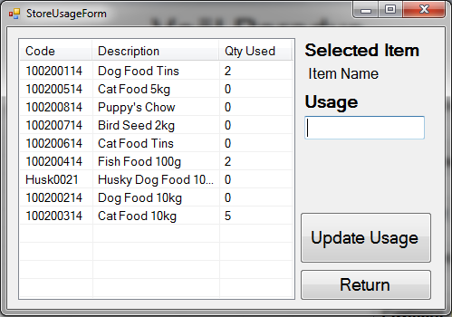

5

4

3

2

1

The store usage window allows an inventory item to be removed from the stock quantity so that the item can be used in the store.

1. The selected items name will appear here
2. The amount of the selected item can be entered here
3. The **Update Usage** button will subtract the number of items from the selected item from the stock in the database. This window will remain active after pressing the button.
4. The **Return** button returns to the **home** screen.
5. The inventory form displays all the stock items in the database (in no particular order).

# Customers

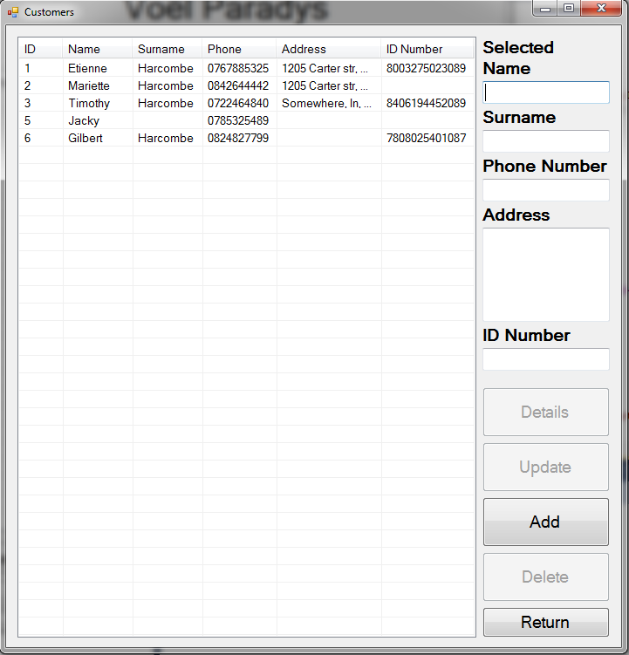

11

8

10

9

7

6

5

4

3

2

1

The customers window is where all the customer details gets managed. Here you can add new customers, update existing customers, delete a selected customer or add wish list items to a customer.

1. Displays the name of the selected customer. Also allows editing of the name for the customer.
2. Displays the surname of the selected customer. Also allows editing of the surname for the customer.
3. Displays the telephone number of the selected customer. Also allows editing of the telephone number for the customer. The telephone number does not do any formatting or checking to make sure that it is in the correct format. It is up to the user to make sure that the number entered is correct.
4. Displays the address of the selected customer. Also allows editing of the address for the customer. The address box is line separated, and allows 5 lines for the address. Separate each line with a press of the enter key.
5. Displays the identity number of the selected customer. Also allows editing of the identity number for the customer.
6. The **Details** button opens the **wish list items** window of the selected customer. If no customer is selected, then the button will be disabled.
7. The **Update** button allows the details of the customer to be updated. If no customer is selected, then the button will be disabled.
8. The **Add** button opens the new customer window where a new customer can be added to the database.
9. The **Delete** button allows the deletion of the selected customer from the database. If no customer is selected, then the button will be disabled.
10. The **Return** button returns to the **Home** screen.
11. The customers form displays all the customers currently in the database. The customers are sorted by ID.

# Customer Details

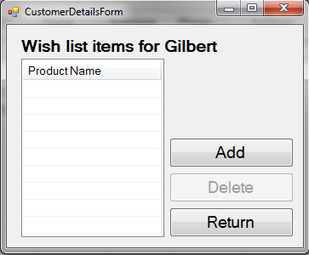

4

3

2

1

The wish list items for the selected customer is displayed when the **Details** button is pressed on the customers window. The wish list items can be added and removed from a customer here to ensure the correct customer is edited.

1. The **Add** button open a dialog window where the name of the requested product can be entered. If the item exists in the inventory database, then the entered name should be exactly as it is in the database to ensure database searches return the correct item. If the item does not exist in the inventory item, then any name can be entered, but when the item is delivered, it must first be added to the inventory database and then given to the customer. This ensures that consistency is maintained in the database.
2. The **Delete** button allows a selected item to be deleted from the wish list. This deletion will not subtract any quantities from the available stock, but should only be used if the customer later decides that he does not require the product.
3. The **Return** button returns to the **Customers** screen.
4. The wish list form displays all the product that the selected customer has in his/her wish list.

# Add Customer

4

3

2

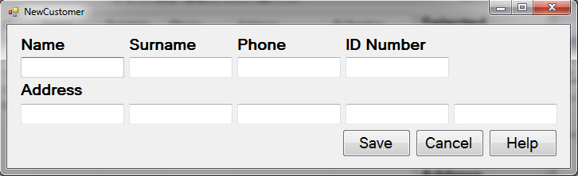

8

7

6

5

1

The add customer windows allows adding a new customer to the database. The only required field for a valid customer is the name of the customer. All the other fields can be blank.

1. The name of the customer can be entered here.
2. The surname of the customer can be entered here.
3. The telephone number of the customer can be entered here. The telephone number does not do any formatting or checking to make sure that it is in the correct format. It is up to the user to make sure that the number entered is correct.
4. The identity number of the customer can be entered here.
5. The address of the customer can be entered here as well as the four other fields to the right. The address only supplies 5 lines. If the address of the customer is more than 5 lines long, separate the rest of the address on line 5 with semi-colons. E.g. Monument park;Pretoria;0181
6. The **Save** button saves the customer to the database and returns to the **Customers** window.
7. The **Cancel** button clears all input and returns to the **Customers** window.
8. The **Help** button opens a help dialog giving basic information about adding a new customer.

# Suppliers

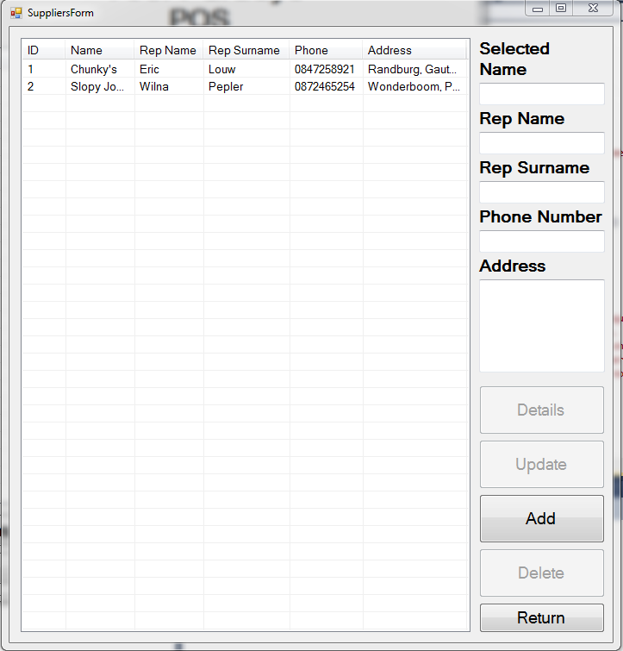

11

10

7

9

8

6

5

4

3

2

1

The suppliers window is where all the supplier details gets managed. Here you can add new suppliers, update existing suppliers, delete a selected supplier or view items supplied by the supplier.

1. Displays the name of the selected supplier. Also allows editing of the name for the supplier.
2. Displays the representative’s name of the selected supplier. Also allows editing of the representative’s name for the supplier.
3. Displays the representative’s surname of the selected supplier. Also allows editing of the representative’s surname for the supplier.
4. Displays the telephone number of the selected supplier. Also allows editing of the telephone number for the supplier. The telephone number does not do any formatting or checking to make sure that it is in the correct format. It is up to the user to make sure that the number entered is correct.
5. Displays the address of the selected supplier. Also allows editing of the address for the supplier. The address box is line separated, and allows 5 lines for the address. Separate each line with a press of the enter key.
6. The **Details** button opens the **details** window of the selected supplier. If no supplier is selected, then the button will be disabled.
7. The **Update** button allows the details of the supplier to be updated. If no supplier is selected, then the button will be disabled.
8. The **Add** button opens the new supplier window where a new supplier can be added to the database.
9. The **Delete** button allows the deletion of the selected supplier from the database. If no supplier is selected, then the button will be disabled.
10. The **Return** button returns to the **Home** screen.
11. The suppliers form displays all the suppliers currently in the database. The suppliers are sorted by ID.

# Supplier Details

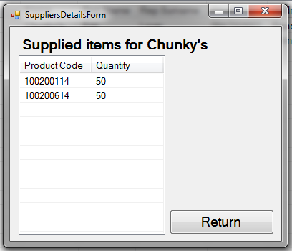

2

1

The supplier details window displays all the items that have been bought from the selected supplier. No other operations can be performed on this window.

1. The **Return** button returns to the **suppliers** window.
2. The supplier details form displays all the products bought from the supplier.

# Add Supplier

4

3

2

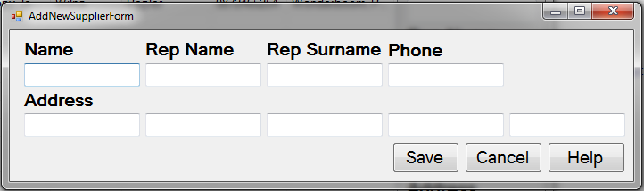

5

1

8

7

6

The add supplier windows allows adding a new supplier to the database. The only required field for a valid supplier is the name of the supplier. All the other fields can be blank.

1. The name of the supplier can be entered here.
2. The representative’s name of the supplier can be entered here.
3. The representative’s surname of the supplier can be entered here.
4. The telephone number of the supplier can be entered here. The telephone number does not do any formatting or checking to make sure that it is in the correct format. It is up to the user to make sure that the number entered is correct.
5. The address of the supplier can be entered here as well as the four other fields to the right. The address only supplies 5 lines. If the address of the customer is more than 5 lines long, separate the rest of the address on line 5 with semi-colons. E.g. Monument park;Pretoria;0181
6. The **Save** button saves the supplier to the database and returns to the **Suppliers** window.
7. The **Cancel** button clears all input and returns to the **Suppliers** window.
8. The **Help** button opens a help dialog giving basic information about adding a new supplier.]

# Orders

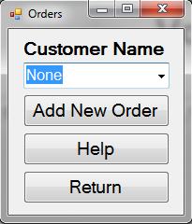

3

2

4

1

The orders window allows wish list items of the customer to be processed. The customer must be selected in the drop down box at 1, and if the customer has more than one wish list item, a dialog window will appear where the items that will be sold can be chosen. Upon selecting the items and accepting them, they will be exported to the **Home** screen where the quantities of the items can be edited, and the sale completed. If there is only one wish list item for the customer, then that item will be directly exported to the **Home** screen where the sale can be completed.

When the items are exported to the **Home** screen, then they are removed from the customer’s wish list items.

Note: The item must exist in the inventory database, otherwise selecting a customer with wish list items will have no effect.

1. Allows the selection of a customer.
2. The **Add New** Customer button opens the customers window where a new wish list item can be assigned to a specified customer.
3. The **Help** button opens a dialog with basic help for the Orders window.
4. The **Return** button returns to the **Home** screen.

# Report

Not been implemented yet, and will be updated once the functionality has been implemented.